System Security: Finished Goods

| August-20 |

**Document Overview**

**Documentation Goals**

This documentation is intended to provide instruction for ***Security within the Finished Good Programs****.*

**Table of Contents**

**Finished Good IU8 Security** 2

Program Master [NS8] 2

Browse Programs 2

View Programs 3

User Groups 3

**Finished Goods Posting by User ID** 4

Program Master [NS8] 4

Browse Programs 4

View Programs 4

# **Finished Good IU8 Security**

## Program Master [NS8]

### Browse Programs

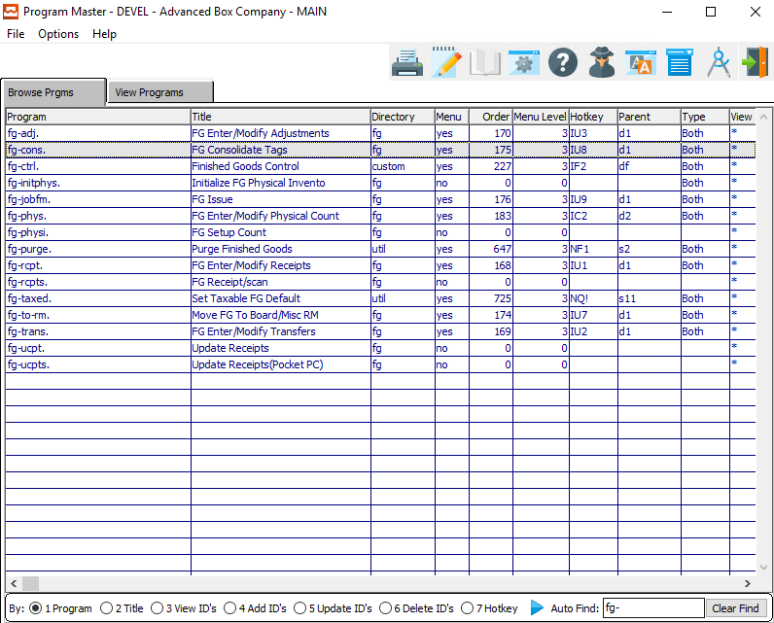

The user can search for their desired program by using the *Auto Find* search box at the bottom of the screen.

Security for *Finished Goods Consolidate Tags* can be found within the (fg-cons.) program.

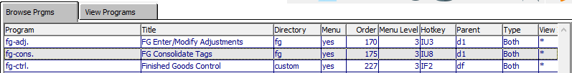

One the system administrator has highlighted their desired program within the list, they may set security by either *User Group* or *User ID* view the *View Programs* tab.

Please Note: *User Groups* are best.

### View Programs

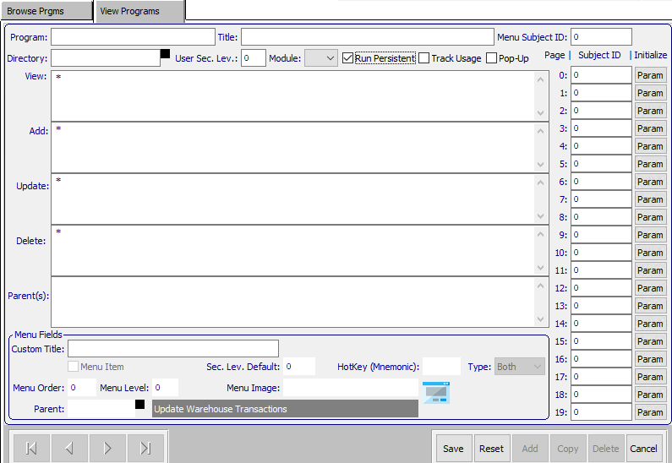

An asterisk (*) within any of these fields means that everyone can access that portion of the program.

#### Run Persistent – Toggle Box

This toggle box must be unchecked for the menu to work properly. If it is checked, the program will lock up after a user accesses this for the first time.



#### View ID’s

The *View ID’s* is to set up who can view the data within the currently selected program.

#### Add ID’s

The *Add ID’s* is security for who can add data within the currently selected program.

#### Update ID’s

The *Update ID’s* is security for who can update existing data within the currently selected program.

#### Delete ID’s

The *Delete ID’s* is security for who can delete existing data within the currently selected program.

### User Groups

Under ***“N”-“U”-“5”***, the user can add groups, and assign users to that group. Then, if a user is hired or fired, the system administrator may simply change the users within the group that the employee belongs to. Therefore, no security will need to be changed.

If a user does not have access, the selected button will be grayed out.

# **Finished Goods Posting by User ID**

## Program Master [NS8]

### Browse Programs

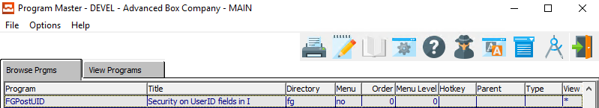

Security for *Finished Goods Posting [IU5]* can be found within the (FGPostUID) program.

### View Programs

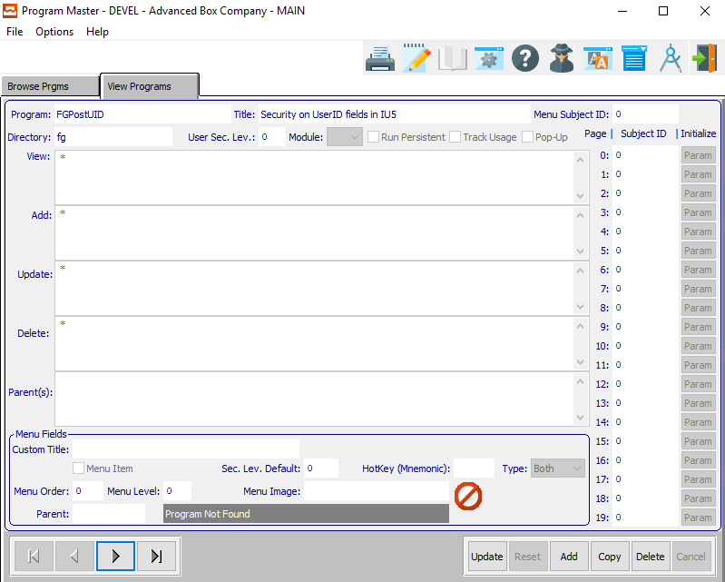

An asterisk (*) within any of these fields means that everyone can access that portion of the program.

#### Update ID’s

The *Update ID’s* is security for who can post transactions that were created by multiple users. Users that are not included within this list can only post transactions that were created by themselves.